CATACOMBS

# Locations:

* Australia – Catacombs of Trinity College, Melbourne
* Austria – Catacombs of St. Stephen's Cathedral, Vienna
* Czech Republic – Catacombs of Znojmo
* Bosnia and Herzegovina – Catacombs of Jajce
* Egypt – Catacombs of Kom el Shoqafa (or Kom al Sukkfa, Shuqafa, etc.) in Alexandria
* England – Catacombs of London and others
* Finland – Catacombs of the Helsinki Orthodox cemetery at Hietaniemi cemetery
* France – Catacombs of Paris. Mine workings were used at end of the 18th century and had no religious purpose other than as an ossuary for storing the bones of cleared graveyards.
* Greece – Catacombs of Milos
* Italy – Catacombs of Rome; Catacombs of Naples; Capuchin catacombs of Palermo, Catacombs of Syracuse and others
* Malta – Catacombs of Malta[5]
* Peru – Catacombs of the Convento de San Francisco, Lima
* Philippines - Catacomb of Nagcarlan Underground Cemetery
* Spain – Catacombs of Sacromonte in Granada
* Serbia - Petrovaradin Fortress catacombs
* Ukraine – Odessa Catacombs
* United States - Old St. Patrick's Cathedral

The first place to be referred to as catacombs was the system of underground tombs between the 2nd and 3rd milestones of the Appian Way in Rome, where the bodies of the apostles Peter and Paul, among others, were said to have been buried.

***Fun fact!***:All Roman catacombs were located outside city walls since it was illegal to bury a dead body within the city, providing "a place…where martyrs tombs could be openly marked" and commemorative services and feasts held safely on sacred days

# Culture:

The **Catacomb culture** was a Bronze Age culture which flourished on the Pontic steppe in 2800–1700 BC.

Originating on the southern steppe as an outgrowth of the Yamnaya culture, the Catacomb culture came to cover a large area. It was probably Indo-European-speaking. Influences of the Catacomb culture have been detected as far as Mycenaean Greece. It spawned the Multi-cordoned ware culture and was eventually succeeded by the Srubnaya culture.

## Burials:

The Catacomb culture is named for its burials. These augmented the shaft grave of the Yamnaya culture with burial niche at its base. This is the so-called catacomb. Such graves have also been found in Mycenaean Greece and parts of Eastern Europe.

Deceased Catacomb individuals were typically buried in a flexed position on their right side. They were often accompanied by ornaments such as silver rings, and weapons such as stone and metal axes, arrows, daggers and maces.

Animal sacrifies, including head and hooves of goats, sheep, horses and cattle, occur in about 16% of Catacomb graves. Cattle sacrifices in the Catacomb culture are more frequent than in the Yamnaya culture. Similar horse burials also appeared in the earlier Khvalynsk culture, and in the Poltavka culture.

Catacomb burials are occasionally covered with Kurgan stelae. This practice was also common in the Yamnaya culture. Some three hundred stelae have been found from the Yamnaya culture and the Catacomb culture.

Catacomb burials are sometimes accompanied by wheeled vehicles. Such wagon burials are attested in the earlier Yamnaya culture, and later among Iranian peoples (Scythians), Celts and Italic peoples.

Aspects of the burial rite of the Catacomb culture have been detected in the Bishkent culture of southern Tajikistan.

In some cases, the skull of deceased Catacomb people was modelled in clay. This involved the filling of the mouth, ears and nasal cavity with clay and modeling the surface features of the face. This practice is associated with high-status burials containing prestige items. The practice was performed on both men, women and children. It has been suggested that these clay masks may have served as a prototype for the later gold masks found in Mycenaean Greece.

# Urban Legends:

## Paris:

1. Secret hideout
   1. In 2004, a group of police officers was exploring a part of the Paris Catacombs restricted from public access and they began to uncover very strange things. First, they found a PA system with pre-recorded guard dog barking noises playing. Then, they found 3,000 square feet of galleries, wired for phones using pirated electricity. The officers found a bar, living area, workshop, lounge, and even a cinema with room to seat 20 people. The cinema seats had been carved into the stones of the Catacombs. The creepiest part was, they saw cameras on the ceilings recording them. The police squad went back to the area a few days later with a larger team to further investigate. Everything they had discovered, from the phone lines to the Paris Catacombs cinema, had vanished. The only thing they found? A note that read: “Ne cherchez pas,” meaning, “don’t search.”
2. The pianist in the lake underneath Opera Garnier
   1. In 1873, a young pianist, Ernest, was disfigured during the fire of the Music Conservatory. His fiancée, a ballerina, died during the fire. Inconsolable and scared of what people would think of his appearance, he sought shelter in Opera Garnier’s vault; and lived right next to the famous lake tank –found underneath Garnier– as a means of protection in case of fire. He devoted the rest of his life to his art and to the completion of his oeuvre: a hymn to love and death. Ernest lived in Opera Garnier’s underground until his death, but his body was never found.
3. Notre Dame and the devil’s door
   1. Biscornet was a young and extremely talented blacksmith from 13th century France. Widely known for his extraordinary work, he was commissioned to create the Notre Dame cathedral’s side doors. Impressed by the responsibility of the task and frightened of losing his reputation, he sought for the Devil’s help. The devil agreed to help in exchange of his soul. Biscornet accepted and the day of the inauguration the doors were a true masterpiece, magnificently forged in a way that no one had seen before. What no one knew was that the doors would not open until they were sprinkled with holy water, saving Biscornet’s soul at the same time.

# Capuchin catacombs of Palermo

## Rosalia Lombardo

Rosalia Lombardo (13 December 1918 – 6 December 1920) was an Italian child who died of pneumonia, resulting from the Spanish flu, one week shy of her second birthday. Rosalia's father, Mario Lombardo, was grieving her death, asked Alfredo Salafia, an embalmer, to preserve her remains. Sometimes called "Sleeping Beauty", hers was one of the last corpses to be admitted to the Capuchin catacombs of Palermo in Sicily

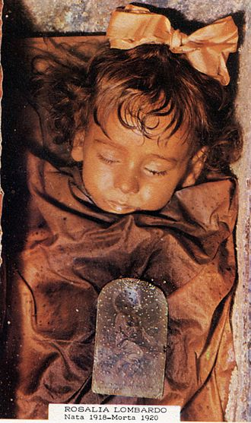

## 

The mummy has achieved further notoriety for a phenomenon in which her eyes appear to open and close several times a day, revealing her intact blue irises. In response to speculation about her moving eyelids, Piombino-Mascali stated that "It's an optical illusion produced by the light that filters through the side windows, which during the day is subject to change ... [her eyes] are not completely closed, and indeed they have never been"

# Catacomb of Priscilla

The Catacomb of Priscilla is an archaeological site on the Via Salaria in Rome, Italy, situated in what was a quarry in Roman times. This quarry was used for Christian burials from the late 2nd century through the 4th century. This catacomb, according to tradition, is named after the wife of the Consul Manius Acilius Glabrio; he is said to have become a Christian and was killed on the orders of Domitian. Some of the walls and ceilings display fine decorations illustrating Biblical scenes.

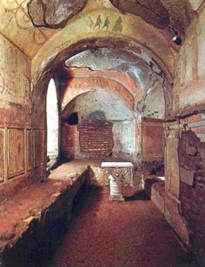

The Capella Greca square chamber with an arch which contains 3rd century frescoes generally interpreted to be Old and New Testament scenes, including the Fractio Panis

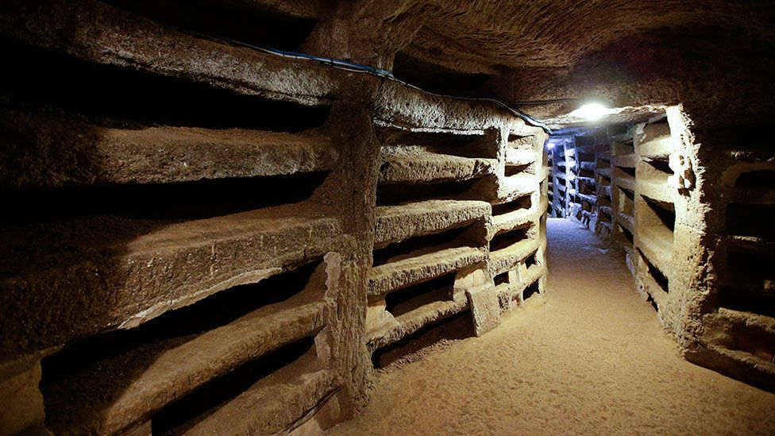

SAMHAIN

## Etymology:

In Modern Irish as well as Scottish Gaelic the name is Samhain, usually with the definite article An tSamhain (Irish), An t-Samhain (Scottish Gaelic) and Yn Tauin (Manx). Older forms of the word include the Scottish Gaelic spellings Samhainn and Samhuinn. The Gaelic names for the month of November are derived from Samhain.

## In Irish Mythology:

Irish mythology was originally a spoken tradition, but much of it was eventually written down in the Middle Ages by Christian monks.

Irish mythology says that Samhain was one of the four seasonal festivals of the year, and the 10th-century tale Tochmarc Emire ('The Wooing of Emer') lists Samhain as the first of these four "quarter days".

The literature says a peace would be declared and there were great gatherings where they held meetings, feasted, drank alcohol,and held contests. hese gatherings are a popular setting for early Irish tales. The tale Echtra Cormaic ('Cormac's Adventure') says that the Feast of Tara was held every seventh Samhain, hosted by the High King of Ireland, during which new laws and duties were ordained; anyone who broke the laws established during this time would be banished.

Samhain was a time when the 'doorways' to the Otherworld opened, allowing supernatural beings and the souls of the dead to come into our world; while Bealtaine was a summer festival for the living, Samhain "was essentially a festival for the dead".

EASTER EGG IDEAS

* Harry Houdini died on Halloween in 1926. Maybe we could hide him somewhere in the background?
* “Furta vel tracta!” means (roughly) trick or treat in Latin. This could be a curse or have it somewhere in the background as “creepy writing”
* Sunt metuis? Hic festus tibi cavos dabit! Means “are you scared? This holiday will give you cavities(hollows)!” (rough translation)